Ethereum client?
An Ethereum client is an implementation of Ethereum’s technical specifications for a specific use case and in a particular programming language. Ethereum clients can be different from each other in several ways; still, they all have the same set of fundamental features. Each is capable of joining the peer-to-peer Ethereum blockchain, synchronizing a local copy of the blockchain, broadcasting a transaction over the blockchain network, and creating and managing accounts. Users interact with the blockchain through client interfaces, and code libraries JSON API does the same.
The following are the most popular and Widely used Ethereum clients.
- Geth - Go implementation.
- OpenEthereum - Rust implementation.
- Nethermind - C#, .NET implementation.
- Besu - Java implementation.
- Trinity - Python implementation.

Monitor nodes with Prometheus and Grafana
The sample network also includes Prometheus and Grafana monitoring tools to let you visualize node health and usage. You can directly access these tools from your browser at the addresses displayed in the endpoint list.
- Prometheus dashboard
- Grafana dashboard
- Grafana Loki logs dashboard
For more details on how to configure and use these tools for your own nodes, see the performance monitoring documentation, Prometheus documentation and Grafana documentation.

Docker overview
Docker is an open platform for developing, shipping, and running applications. Docker enables you to separate your applications from your infrastructure so you can deliver software quickly. With Docker, you can manage your infrastructure in the same ways you manage your applications. By taking advantage of Docker's methodologies for shipping, testing, and deploying code, you can significantly reduce the delay between writing code and running it in production.
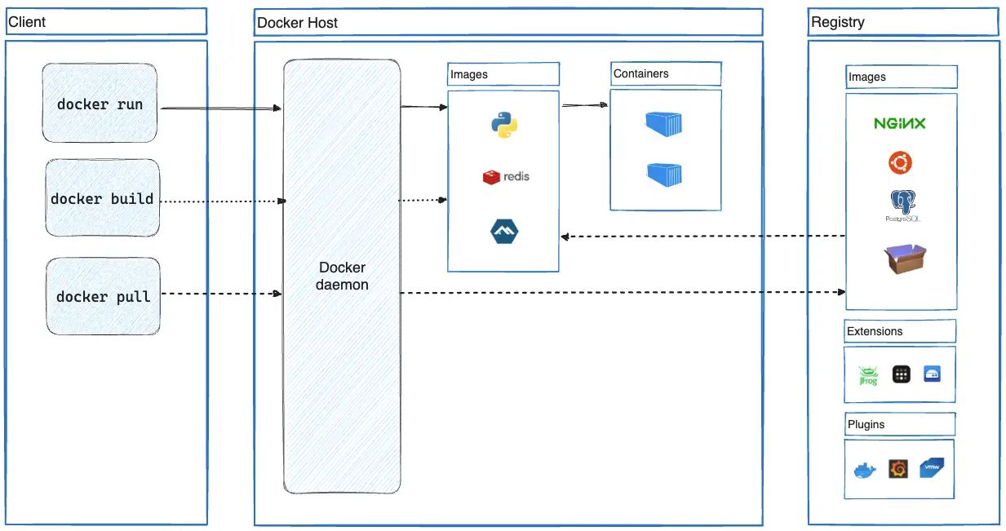

Docker registries
A Docker registry stores Docker images. Docker Hub is a public registry that anyone can use, and Docker looks for images on Docker Hub by default. You can even run your own private registry.
When you use the docker pull or docker run commands, Docker pulls the required images from your configured registry. When you use the docker push command, Docker pushes your image to your configured registry.

Images
An image is a read-only template with instructions for creating a Docker container. Often, an image is based on another image, with some additional customization. For example, you may build an image which is based on the ubuntu image, but installs the Apache web server and your application, as well as the configuration details needed to make your application run.
You might create your own images or you might only use those created by others and published in a registry. To build your own image, you create a Dockerfile with a simple syntax for defining the steps needed to create the image and run it. Each instruction in a Dockerfile creates a layer in the image. When you change the Dockerfile and rebuild the image, only those layers which have changed are rebuilt. This is part of what makes images so lightweight, small, and fast, when compared to other virtualization technologies.

Containers
A container is a runnable instance of an image. You can create, start, stop, move, or delete a container using the Docker API or CLI. You can connect a container to one or more networks, attach storage to it, or even create a new image based on its current state.
By default, a container is relatively well isolated from other containers and its host machine. You can control how isolated a container's network, storage, or other underlying subsystems are from other containers or from the host machine.
A container is defined by its image as well as any configuration options you provide to it when you create or start it. When a container is removed, any changes to its state that aren't stored in persistent storage disappear.

Example docker run command
The following command runs an ubuntu container, attaches interactively to your local command-line session, and runs /bin/bash.
docker run -i -t ubuntu /bin/bash
When you run this command, the following happens (assuming you are using the default registry configuration):
- If you don't have the ubuntu image locally, Docker pulls it from your configured registry, as though you had run docker pull ubuntu manually.
- Docker creates a new container, as though you had run a docker container create command manually.
- Docker allocates a read-write filesystem to the container, as its final layer. This allows a running container to create or modify files and directories in its local filesystem.
- Docker creates a network interface to connect the container to the default network, since you didn't specify any networking options. This includes assigning an IP address to the container. By default, containers can connect to external networks using the host machine's network connection.
- Docker starts the container and executes /bin/bash. Because the container is running interactively and attached to your terminal (due to the -i and -t flags), you can provide input using your keyboard while Docker logs the output to your terminal.
- When you run exit to terminate the /bin/bash command, the container stops but isn't removed. You can start it again or remove it.

Meet --holesky, the first long-standing, merged-from-genesis, public Ethereum testnet. Holešky will replace Goerli as a staking, infrastructure and protocol-developer testnet in 2023. For testing decentralized applications, smart contracts, and other EVM functionality, please use Sepolia!

